**CHPATER -14**

**A Very Graphic Story**

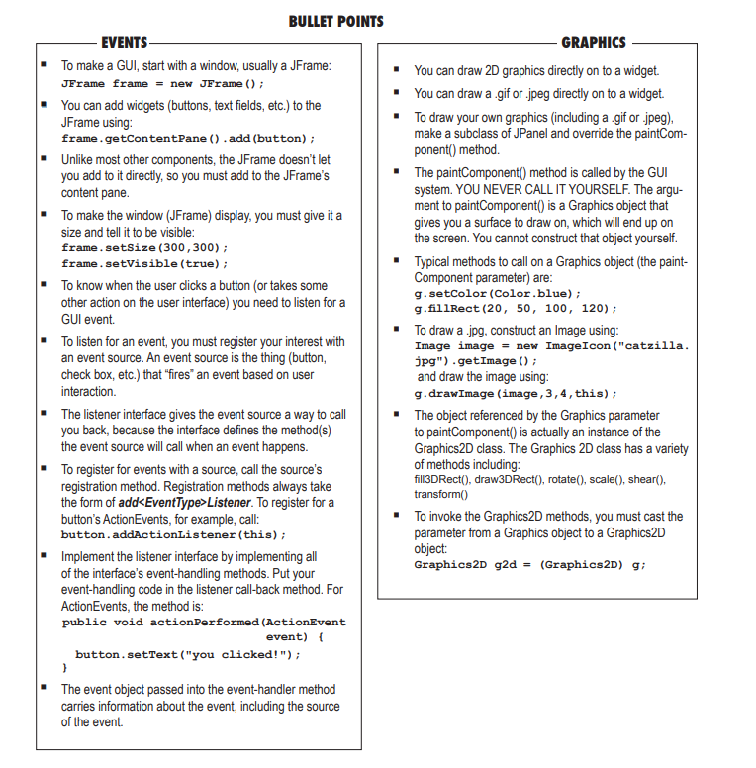

* **Check Box**:
* itemStateChanged()
* actionPerformed()
* focusGained()
* **Text Field**:
* actionPerformed()
* keyTyped()
* focusGained()
* **Scrolling List**:
* itemStateChanged()
* focusGained()
* **Button**:
* actionPerformed()
* focusGained()
* mousePressed()
* **Dialog Box**:
* windowClosing()
* focusGained()
* **Radio Button**:
* itemStateChanged()
* actionPerformed()
* focusGained()
* **Menu Item**:
* actionPerformed()
* focusGained()

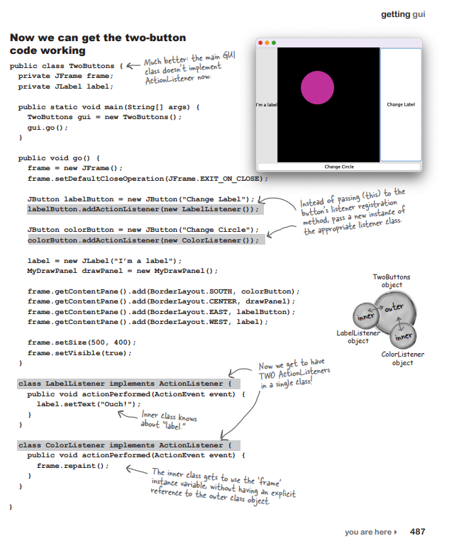

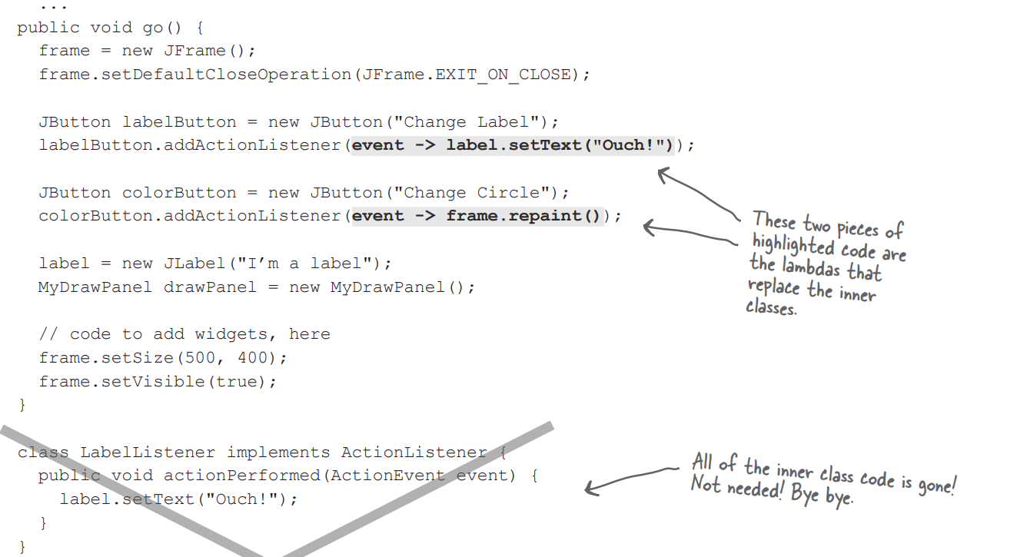

**EXERCISE**

**1.WHO AM I?**

**I got the whole GUI, in my hands. -** JFrame click it.  
**Every event type has one of these.** **-** Listener interface

**The listener’s key method.**-actionPerformed()

**This method gives JFrame its size.**-setSize()

**You add code to this method but never call it.**-paintComponent()

**When the user actually does something, it’s an ____ .**-event

**Most of these are event sources.**-swing components

**I carry data back to the listener.**-event object

**An addXxxListener( ) method says an object is an ___ .**

**How a listener signs up.**-addXxxListener()

**The method where all the graphics code goes.**-paintComponent()

**I’m typically bound to an instance.**-inner class

**The “g” in (Graphics g) is really of this class.**-Graphics2D

**The method that gets paintComponent() rolling.**-repaint()

**The package where most of the Swingers reside.**-javax.swing

**2.BE THE COMPILER**

import javax.swing.*;

import java.awt.*;

import java.awt.event.*;

class InnerButton {

private JButton button;

public static void main(String[] args) {

InnerButton gui = new InnerButton();

gui.go();

}

public void go() {

JFrame frame = new JFrame();

frame.setDefaultCloseOperation(JFrame.EXIT_ON_CLOSE);

button = new JButton("A");

button.addActionListener(new ButtonListener());

frame.getContentPane().add(BorderLayout.SOUTH, button);

frame.setSize(200, 100);

frame.setVisible(true);

}

class ButtonListener implements ActionListener {

public void actionPerformed(ActionEvent e) {

if (button.getText().equals("A")) {

button.setText("B");

} else {

button.setText("A");

}

}

}

}

**3.POOL PUZZLE**

import javax.swing.*;

import java.awt.*;

import java.util.concurrent.TimeUnit;

public class Animate {

int x = 1;

int y = 1;

public static void main(String[] args) {

Animate gui = new Animate();

gui.go();

}

public void go() {

JFrame frame = new JFrame();

frame.setDefaultCloseOperation(JFrame.EXIT_ON_CLOSE);

MyDrawP drawP = new MyDrawP();

frame.getContentPane().add(drawP);

frame.setSize(500, 270);

frame.setVisible(true);

for (int i = 0; i < 124; i++, y++, x++) {

x++;

drawP.repaint();

try {

TimeUnit.MILLISECONDS.sleep(50);

} catch (Exception ex) {

}

}

}

class MyDrawP extends JPanel {

public void paintComponent(Graphics g) {

g.setColor(Color.white);

g.fillRect(0, 0, 500, 250);

g.setColor(Color.blue);

g.fillRect(x, y, 500 - x * 2, 250 - y * 2);

}

}

}